Friday, 8/26/22 | DORKS CORNER  Latest News and Updates on the DORKS |  |  |  |  | Issue #1
DORKS Bags Tournament  Joe Greco - Chairman  Longtime DORKS member Joe Greco is Chairing the Annual DORKS Bags Tournament October 15th, 2022, at the Rosati-Kain High School Gym. Doors open at 3:15pm.  Mr. Greco has vowed to make this year’s event a real success. The last two years Covid has cancelled out the tournament.  At the meeting August 17th, Joe mentioned that he’s still in need of volunteers, donations, and of course more teams.  Great fun for husband/wife, Parent/Child or just Friend/Friend teams.  See the flyer to register or to help in anyway. |  |  |  | 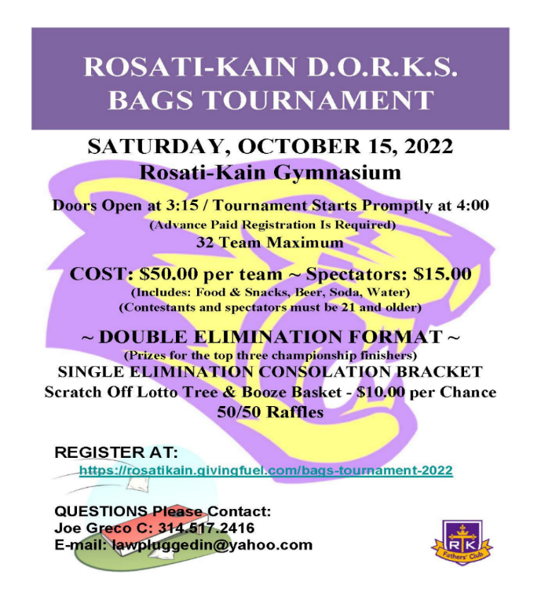
DORKS NFL Survivor Pool  Bob Welsch – Chairman |  |  | DORKS turn Rosati into Caesars Palace |  | Other Dorks Upcoming Events
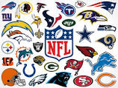  Think you can pick NFL games? Looking for a way to make Sunday’s game more fun? Or maybe you’re just lucky. Well, you’re in luck. Thanks to DORKS Treasurer Bob Welsch, the DORKS are introducing their first annual NFL Survival Pool.  Pick a winner each week and continue until you win the jackpot. Pick as many teams as you would like. Cost is $25 per entry. Follow the link below and let the games begin.  https://www.runyourpool.com/join/pool_info.cfm?id=278083&p=uaptun |  |  | Darren Vehlewald–Chairman  Take a trip to Vegas without leaving St. Louis. Thanks to the DORKS, on January 14th, 2023, RK will be transformed into Caesars Palace. That’s when the DORKS will be hosting the first annual Casino Night in the gym at Rosati-Kain.  Blackjack, Poker, Chuck-a-luck tables and more. Craps and Roulette tables as well. There will also be Pull-tabs and raffles.  For only $50 you will receive $1,000 worth of chips (yes I said $1,000), for your gaming pleasure. For $125 you can be a sponsor and put your or your company’s name on a table. |  | September 21st, 2023, the DORKS will be meeting in the RK Commons 7pm – 8pm. We will be discussing upcoming events and further ways to help the school. Go to the Signup genius that will be coming and RSVP.  Second Annual Texas Hold’em Tournament will be held in the spring in the RK Cafeteria.  Kickball Tournament between the classes will be held in conjunction with the Father/Daughter BBQ in May.  Mouse Races, a Golf Tournament and a Parent and Faculty only Pig Roast is being planned.

